The Hallmarks of Links to Learning

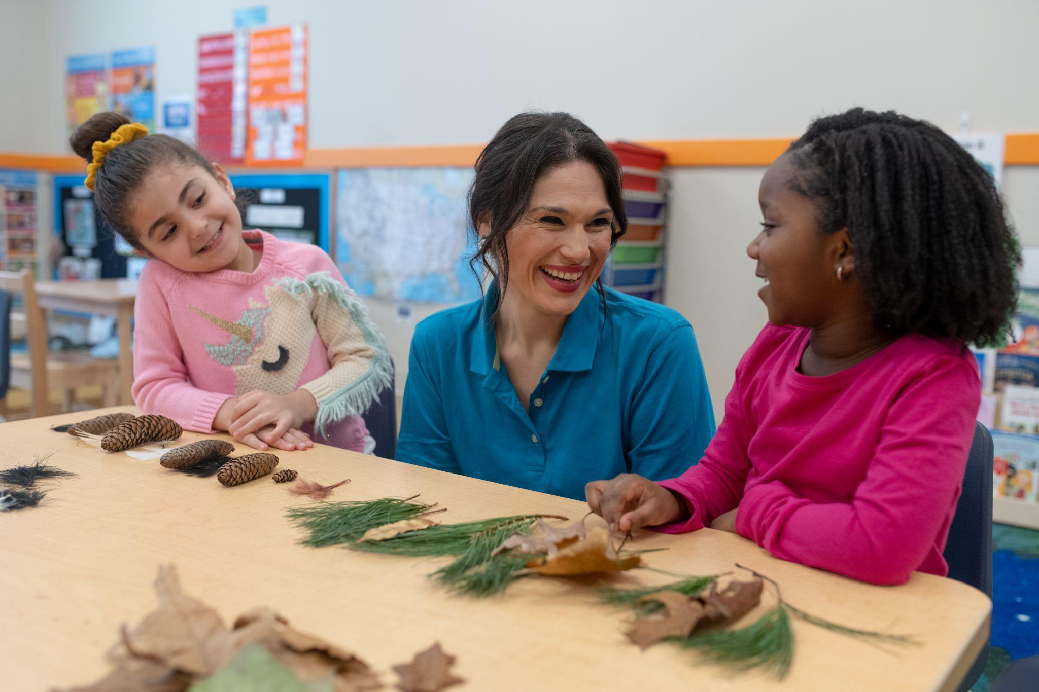

At the heart of our Links to Learning curriculum lie five hallmarks: Social-Emotional Learning, Center-Based Learning, Literacy-Based Curriculum, Personalized Learning, and Family Communication. These key features help us foster an environment where students can explore, discover, and thrive. Let’s take a closer look at each hallmark – what they are and how you’ll see them in our classrooms!

Social-Emotional Learning

From learning to share and taking turns to making friends and managing emotions, social-emotional skills are integrated into everything we do. Every activity in our classrooms is designed to help students build confidence and independence needed for a lifetime of learning. Our days begin with students taking turns participating in Circle Time, recognizing how they feel that day, and learning about emotions. We sing songs and read books about emotions, encourage collaboration among peers, and create an inclusive environment where individuality is celebrated. Our teachers are positive role models for their students and are there to help when emotions rise and celebrate when kindness conquers.

Center-Based Learning

Centers are defined areas of our classroom that allow for hands-on play-based learning in small groups and help children make connections between abstract concepts and real-world experiences. Centers help build problem-solving, communication, and self-regulation skills, and are continuously changing, keeping student interest alive. For example, you may find our construction center filled with various building materials and pig figurines when students are reading The Three Little Pigs! By providing children with the opportunity to explore new materials with a small group of classmates every day, we are igniting their imagination, sparking new interests, and helping them develop social skills.

Literacy-Based Curriculum

Our teachers build learning experiences centered around captivating books and provide students with constant access to printed text. Students forge meaningful connections between words and illustrations and ask questions sparked by their natural curiosity. Teachers label classroom materials with photographs and words, facilitating familiarity and promoting independence. Many of the activities in the centers that students visit are related to the books they are reading, further helping to bring literature and ideas to life. Additionally, you’ll find nature books in the science center, books with famous artworks near the easel, counting books in the math center, and more throughout our classrooms!

Personalized Learning

Teachers employ a wide range of strategies to ensure that every student’s educational journey is uniquely tailored to their needs and we are offering the best preschool curriculum. Through small group interactions, they fine-tune lessons to match each student’s pace of growth and development. They keep an ongoing checklist of milestones their students have reached so they know where each student may need assistance or be challenged further. We cultivate an inclusive environment where every child feels valued, welcome, and empowered.

Family Communication

Our teachers and school leaders strive to make communication as seamless as possible, giving you one less thing to worry about. You’ll find our teachers greeting you and your child with a smile each day and offering information on how their day went at pick-up. Utilizing our communication app, Links 2 Home, we send photos and information on meals, sleep, diaper changes/potty times, and more. You’ll receive a complete daily report after pick-up each day. Monthly folders with samples of your child’s work are sent home at the end of each month so you are in the know about your child’s progress. Conferences are offered throughout the year, but we are happy to schedule times to listen and learn ways that we can best serve you and your family anytime.

To view our Hallmarks in action, visit our [Links to Learning Youtube Channel](https://www.youtube.com/watch?v=XT2FGJOp0mA&list=PLUlE6vAOKpIJtRvzPMSSOHKdrHtHmmG-E)!