**Joyful Learning and Strong Foundations: Week of the Young Child at Our School**

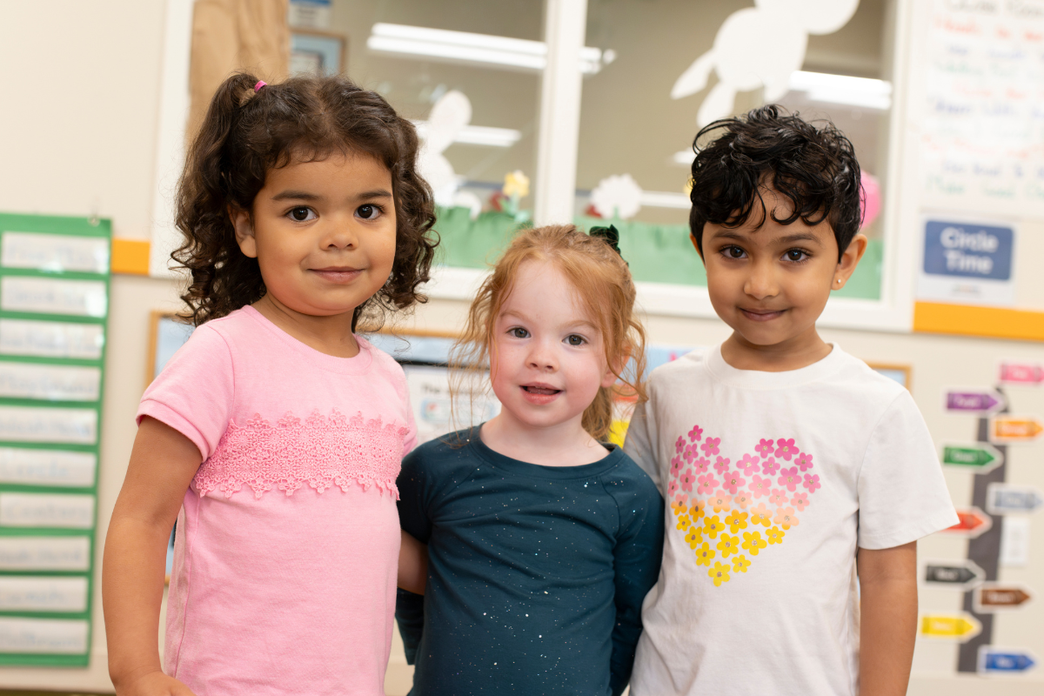

Every April, our school proudly celebrates Week of the Young Child. This meaningful event, hosted by the National Association for the Education of Young Children (NAEYC), recognizes the importance of early childhood education. It is an opportunity to honor the families and teachers who help children learn and grow each day. During this week, children enjoy activities that spark creativity, curiosity, and learning. By celebrating, we are reaffirming and recommitting our responsibility to ensure every child gains early learning experiences that build a strong foundation for the future.

The activities we engage in during Week of the Young Child highlight the everyday experiences we offer, all grounded in our Links to Learning curriculum. Each day has a unique theme that helps children build new skills in exciting, hands-on ways. Here are some of the ways we celebrate in our school:

**Music Monday**

On Music Monday, children sing, dance, and play instruments. They listen to music spanning different genres and cultures, moods, and tempos. Students have fun clapping along to the beat, moving their bodies to the rhythm, singing along with songs, and playing instruments - some made in class! These activities help them develop language and literacy skills, recognize patterns, and boost their creativity.

**Tasty Tuesday**

Tasty Tuesday is all about food! Our students mix, measure, and try new flavors while learning about math and science. They also discuss healthy eating habits and practice table manners like saying “please” and “thank you” and cleaning up after meals.

**Work Together Wednesday**

Work Together Wednesday strengthens collaboration and community in the classroom. Our students are encouraged to share ideas, solve problems, and work together to build, create, and play games. These activities help children practice kindness, respect, and teamwork while recognizing the unique strengths of their classmates. By working toward a common goal, they build confidence, form meaningful connections, and see firsthand how cooperation makes a big difference.

**Artsy Thursday**

Our students become little artists on Artsy Thursday! Children use materials such as chalk, paint, and clay in fun ways. They might spray paint with water bottles, mold clay into 3D designs, or create works of art inspired by famous artists. These activities help children use their imagination, develop small muscle strength, and build confidence. Our teachers focus on the joy of creating, not just the final piece!

**Family Friday**

On Family Friday, students share pictures and stories about their lives and traditions, helping them learn what makes each family special. We believe working together with families helps children learn and grow, so we celebrate the different cultures in our community through books and discussions, helping children develop a deeper understanding and appreciation for diversity. Since school is like a second home, Family Friday is also a time to celebrate our school family! We invite our families to join in special celebrations with us.

Week of the Young Child highlights the importance of early learning and the joy of discovery. We love celebrating this special week and the families, teachers, and communities that help our students thrive.

To learn more about how our Links to Learning curriculum and dedicated teachers support our students academically, socially, and emotionally, contact us today!